EXPT NO:5A | DATA VISUALIZATION USING MATPLOTLIB –  SPACE MISSION DATA

Aim:
To visualize dataset features and distributions using line charts, bar charts, pie charts, histograms, scatter plots, and box plots using Matplotlib.

Algorithm:
ALGORITHM 1: LINE CHART
Objective: To visualize the yearly trend of space mission launches.
Steps
- Load the space mission dataset.
- Select the Year and number of launches.
- Plot the yearly launches using a line chart.
- Add title and axis labels.
- Display the graph.
Interpretation
The line chart shows how the number of launches varies across different years and helps identify the launch trend.
# Program 1: Line Chart
plt.plot(years, launches)
plt.title("Yearly Space Mission Launches")
plt.xlabel("Year")
plt.ylabel("Number of Launches")
plt.show()

ALGORITHM 2: BAR CHART
Objective: To compare the number of launches across different organisations.
Steps
- Select the Organisation and launch count.
- Create a bar chart using the top organisations' launch values.
- Add title and axis labels.
- Display the chart.
Interpretation
The bar chart helps compare the number of launches carried out by different organisations.
# Program 2: Bar Chart
plt.bar(organisations, launches)
plt.title("Top Organisations by Launches")
plt.xlabel("Organisation")
plt.ylabel("Number of Launches")
plt.show()

ALGORITHM 3: PIE CHART
Objective: To visualize the distribution of mission outcomes.
Steps
- Select the Mission Status values.
- Create a pie chart using the mission status counts.
- Display percentage labels.
- Add a suitable title.
- Display the chart.
Interpretation
The pie chart shows the percentage share of each mission outcome such as Success, Failure, Partial Failure and Prelaunch Failure.
# Program 3: Pie Chart
plt.pie(status_counts, labels=status, autopct="%1.1f%%")
plt.title("Mission Status Distribution")
plt.show()

ALGORITHM 4: HISTOGRAM
Objective: To visualize the distribution of launch prices.
Steps
- Select the Price column.
- Divide the price values into bins.
- Create a histogram.
- Add title and axis labels.
- Display the histogram.
Interpretation
The histogram shows the frequency distribution of the launch price values.
# Program 4: Histogram
plt.hist(price, bins=20)
plt.title("Launch Price Distribution")
plt.xlabel("Price (USD Millions)")
plt.ylabel("Frequency")
plt.show()

ALGORITHM 5: SCATTER PLOT
Objective: To visualize the launch price values across different years.
Steps
- Select Year as the X-axis variable.
- Select Price as the Y-axis variable.
- Create a scatter plot.
- Add title and axis labels.
- Display the graph.
Interpretation
The scatter plot shows the variation in launch price across different years.
# Program 5: Scatter Plot
plt.scatter(year, price)
plt.title("Launch Price across Years")
plt.xlabel("Year")
plt.ylabel("Price (USD Millions)")
plt.show()

ALGORITHM 6: BOX PLOT
Objective: To visualize the distribution of launch prices.
Steps
- Select the Price column.
- Create a box plot.
- Add a suitable title and axis label.
- Display the plot.
Interpretation
The box plot shows the distribution of launch price values and helps identify possible outliers.
# Program 6: Box Plot
plt.boxplot(price)
plt.title("Launch Price Box Plot")
plt.ylabel("Price (USD Millions)")
plt.show()

ALGORITHM 7: MULTIPLE LINE CHARTS
Objective: To compare successful and failed launches across different years.
Steps
- Store the success and failure counts.
- Plot the success values using a line chart.
- Plot the failure values using another line chart.
- Add title, axis labels and legend.
- Display the graph.
Interpretation
The multiple line chart compares the success and failure launch counts across different years.
# Program 7: Multiple Line Charts
plt.plot(years, success, label="Success")
plt.plot(years, failure, label="Failure")
plt.title("Success vs Failure Launches per Year")
plt.xlabel("Year")
plt.ylabel("Number of Launches")
plt.legend()
plt.show()

Output:
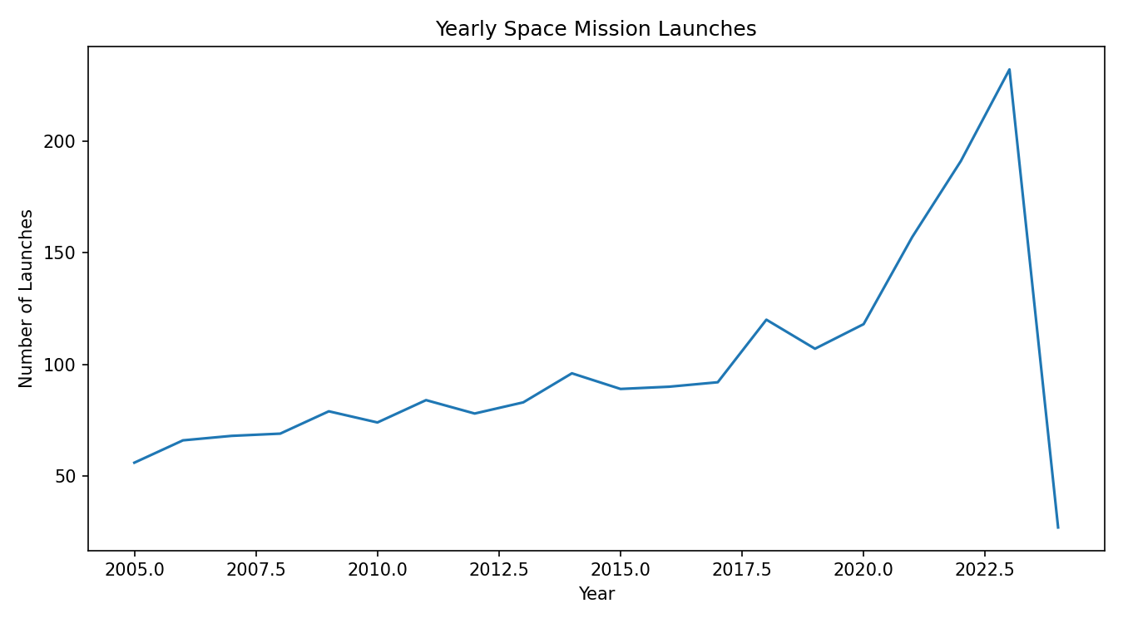
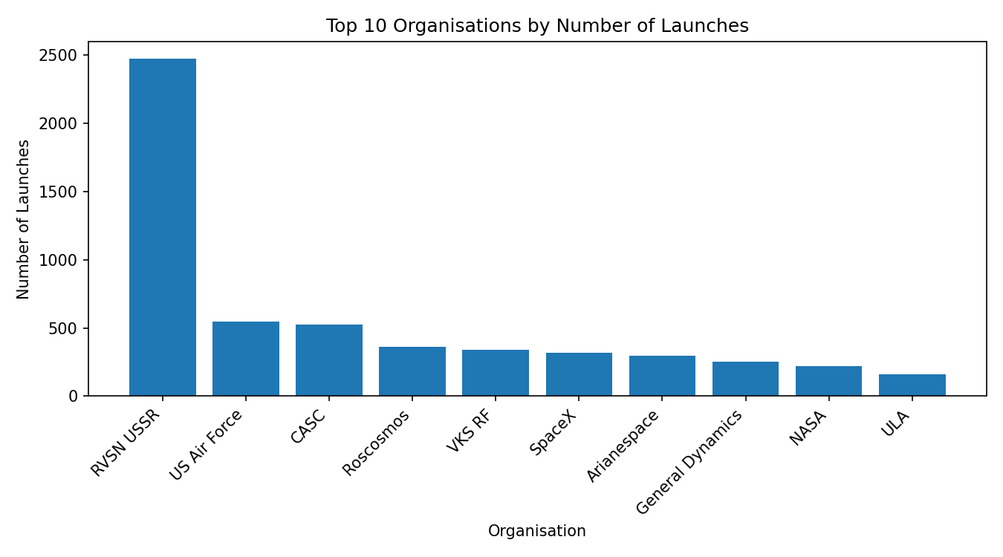
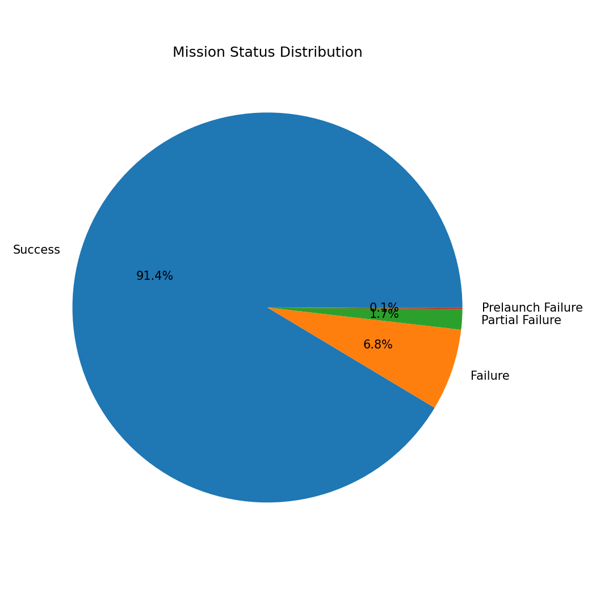
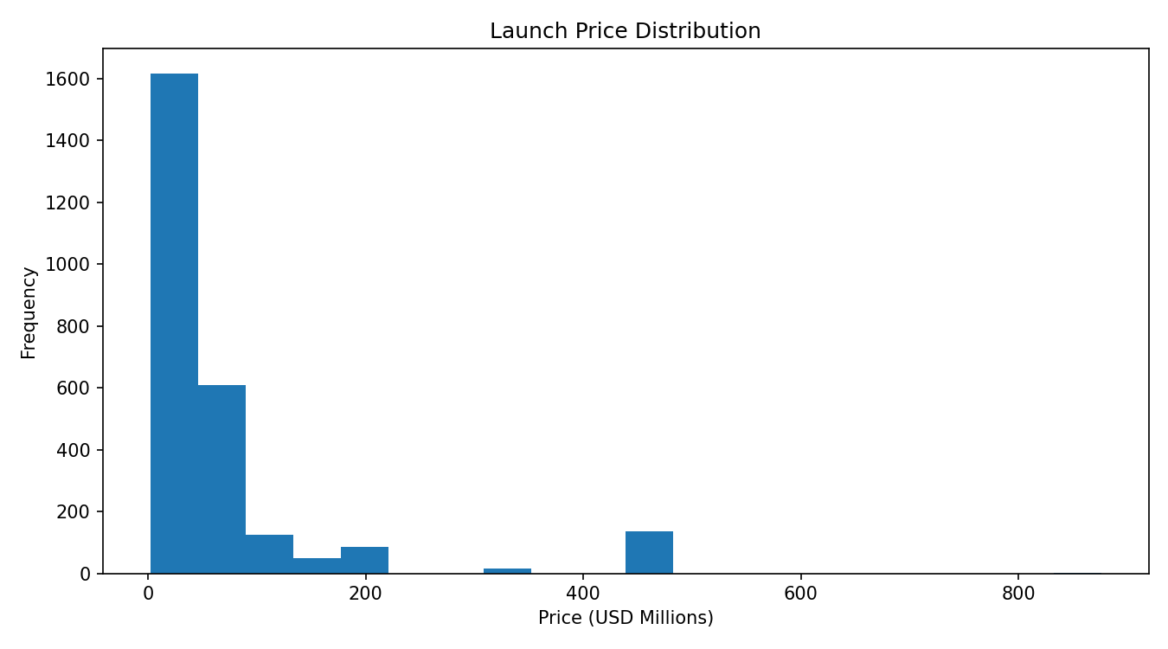
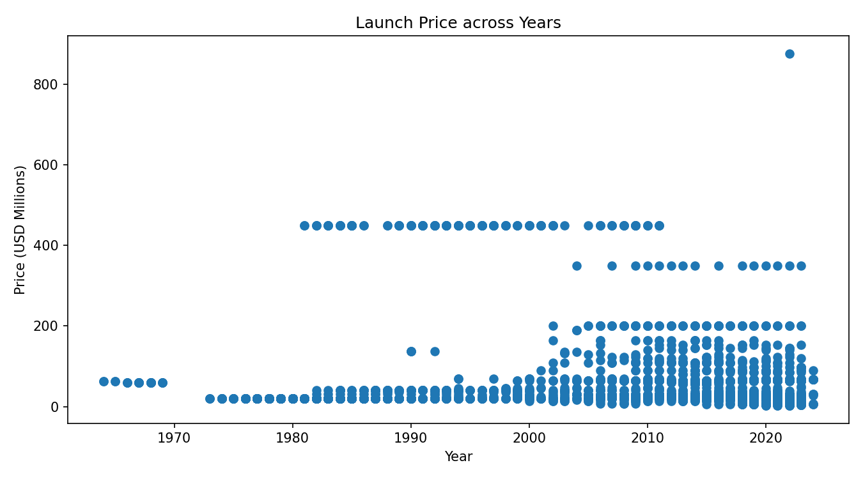
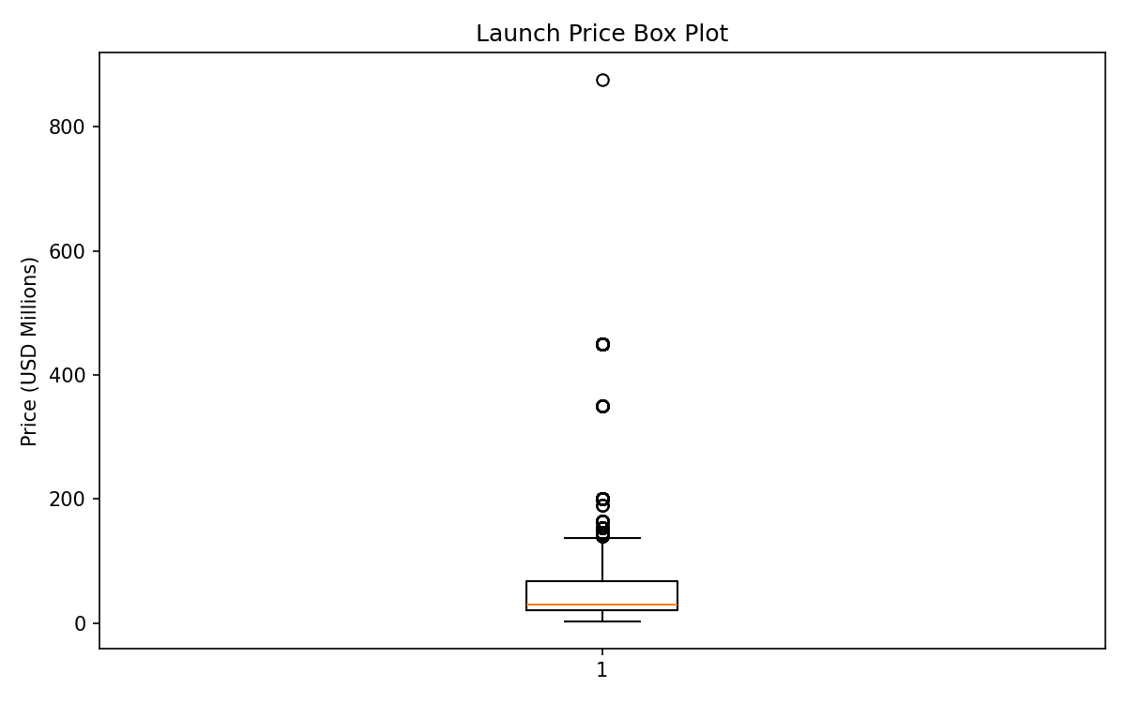
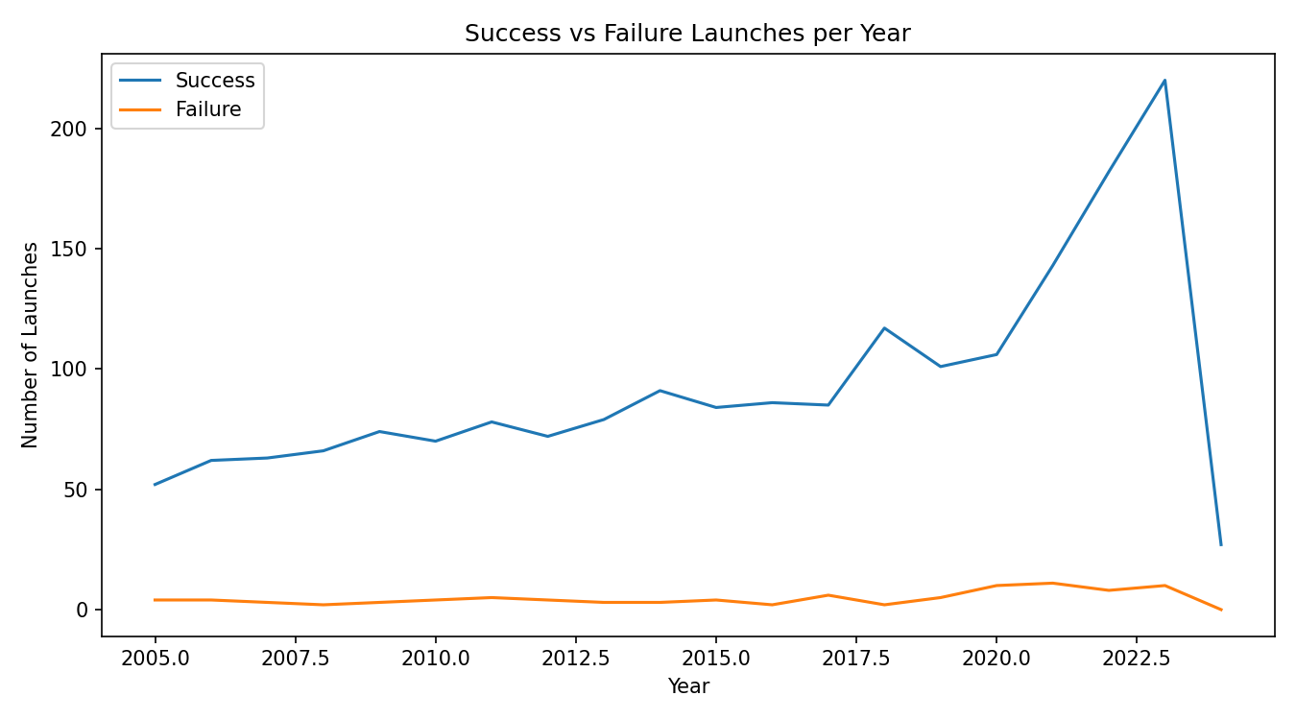
Result:

EXPT NO:5B | DATA VISUALIZATION

AIM:
To visualize the Global Space Mission Launches dataset using Python and create different charts to understand organisation performance, launch price distribution, mission outcomes, and identify important patterns.

PROCEDURE:
- Start the program.
- Import Pandas, Matplotlib, and Seaborn libraries.
- Load the Space Mission Launches CSV dataset.
- Display the first few records using head().
- Identify the numerical columns using select_dtypes().
- Create a bar chart to compare the top organisations based on number of launches.
- Create a line chart to analyze the launch price of the first 20 missions.
- Create a pie chart to show the launch share of the top 10 organisations.
- Create a box plot to identify the distribution and outliers in launch price.
- Create a histogram to observe the frequency distribution of launch price.
- Add suitable titles, axis labels, legends, and grid lines.
- Display all the visualizations.
- Analyze the graphs and identify important patterns.
- Stop the program.

CODE:
import pandas as pd
import matplotlib.pyplot as plt
import seaborn as sns

# Load Space Mission Launches dataset
df = pd.read_csv("all_space_mission_launches.csv")

# Display dataset
print("Dataset Preview:")
print(df.head())

# Select numerical columns
num_cols = df.select_dtypes(include="number").columns

print("\nNumerical columns:")
print(num_cols.tolist())

#
# 1. BAR CHART
#
top10 = df["Organisation"].value_counts().head(10)

plt.figure(figsize=(10,5))
plt.bar(top10.index, top10.values)

plt.title(
"All Space Mission Launches - Bar Chart"
)

plt.xlabel("Organisation")
plt.ylabel("Number of Launches")

plt.xticks(
rotation=45, ha="right"
)

plt.tight_layout()
plt.show()

#
# 2. LINE CHART
#
first20 = df.head(20)
plt.figure(figsize=(9,5))
plt.plot(
range(1, len(first20) + 1),
first20["Price"], marker="o"
)

plt.title(
"All Space Mission Launches - Line Chart"
)

plt.xlabel("Mission Record")
plt.ylabel("Price (USD Millions)")
plt.grid()

plt.tight_layout()
plt.show()

#
# 3. PIE CHART
#
plt.figure(figsize=(7,7))
plt.pie(
top10.values,
labels=top10.index, autopct="%1.1f%%"
)

plt.title(
"All Space Mission Launches - Top 10 Organisation Share"
)

plt.tight_layout()
plt.show()

#
# 4. BOX PLOT
#
plt.figure(figsize=(8,5))

sns.boxplot(
y=df["Price"]
)

plt.title(
"All Space Mission Launches - Box Plot"
)

plt.ylabel("Price (USD Millions)")

plt.tight_layout()
plt.show()

#
# 5. HISTOGRAM
#
plt.figure(figsize=(8,5))
plt.hist(
df["Price"],
bins=15
)

plt.title(
"All Space Mission Launches - Histogram"
)

plt.xlabel("Price (USD Millions)")
plt.ylabel("Frequency")

plt.tight_layout()
plt.show()

OUTPUT:
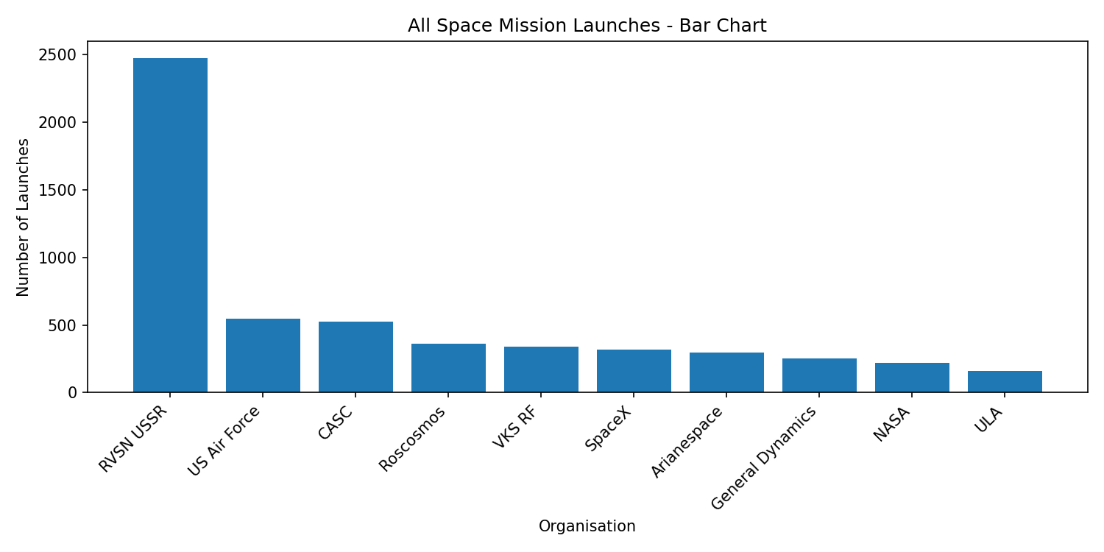
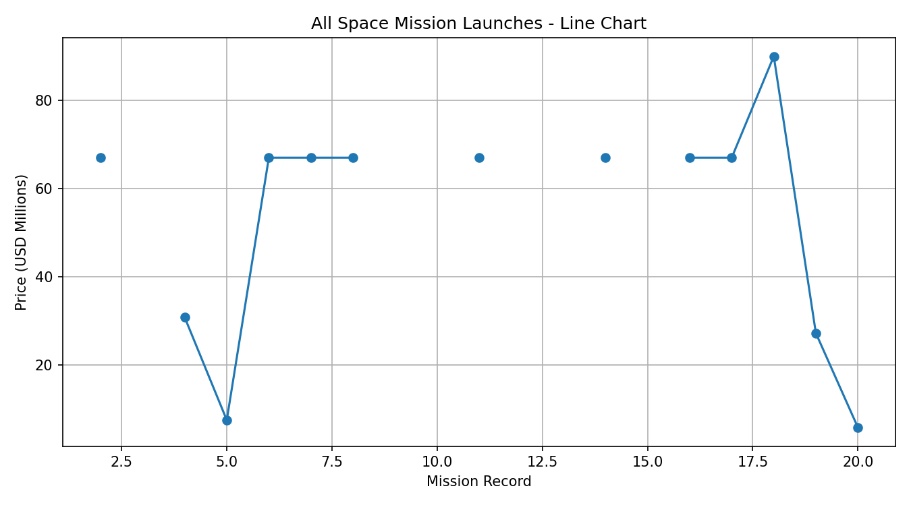
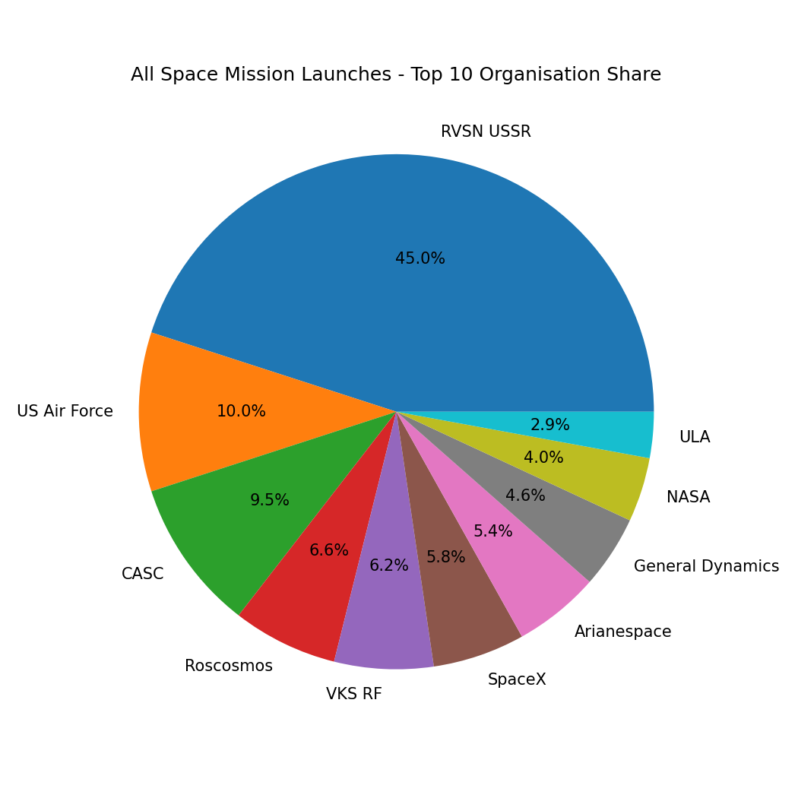
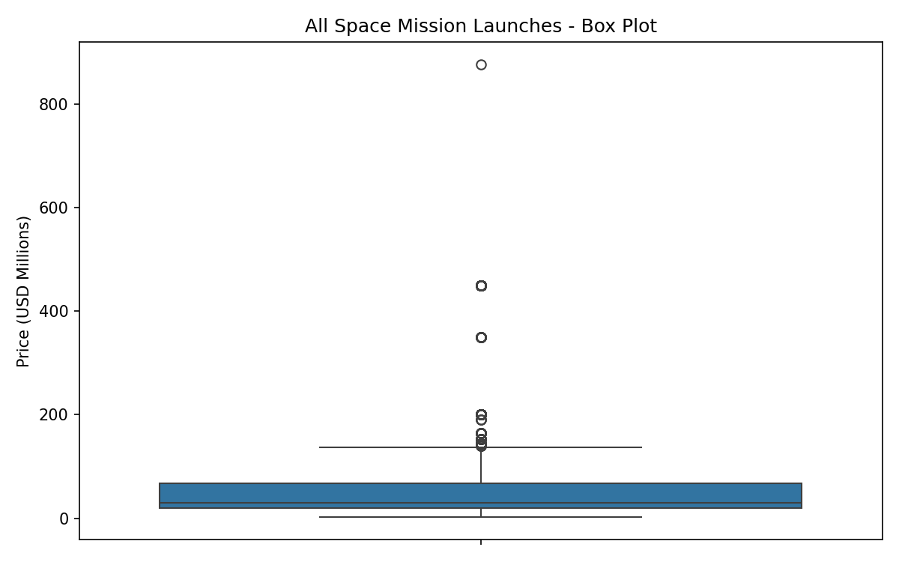
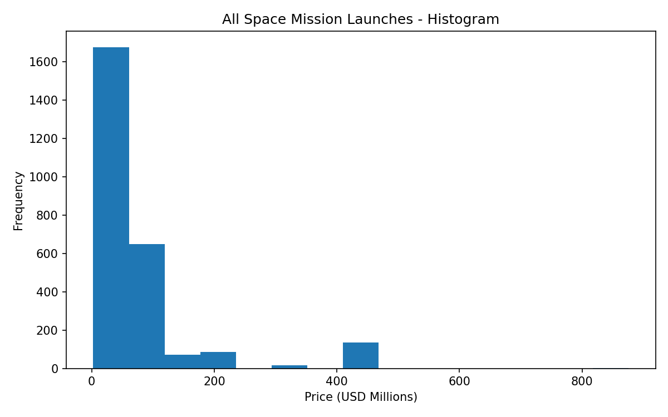
Result:

